Bootstrap 5 Colors

## **Text Colors**

Bootstrap 5 has some contextual classes that can be used to provide "meaning through colors".

The classes for text colors are: .text-muted, .text-primary, .text-success, .text-info, .text-warning, .text-danger, .text-secondary, .text-white, .text-dark, .text-body (default body color/often black) and .text-light:

### **Example**

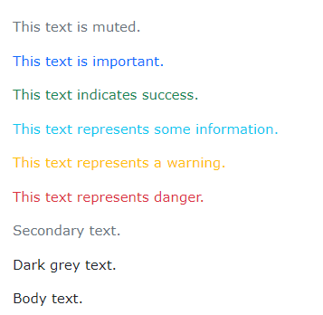

You can also add 50% opacity for black or white text with the .text-black-50 or .text-white-50 classes:

### **Example**

## 

## **Background Colors**

The classes for background colors are: .bg-primary, .bg-success, .bg-info, .bg-warning, .bg-danger, .bg-secondary, .bg-dark and .bg-light.

Note that background colors do not set the text color, so in some cases you'll want to use them together with a .text-* color class.

### **Example**

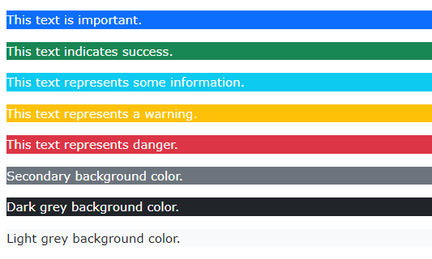

References

<https://www.w3schools.com/bootstrap5/bootstrap_colors.php>